

Class: **BSE-6 (A/B)**

BAHRIA UNIVERSITY (KARACHI CAMPUS)

ASSIGNMENT # 2 - SPRING 2023

**Cloud Computing** (**SEN-325**)

**[CLO 3]**

Max Marks: **5**

Course Instructor: **Engr. Muhammad Faisal**

[The marks of this assignment may increase or decrease]

**Read Carefully:**

* The deadline for this assignment is *before* or *on* **Monday, 27th May, 2023.**

**WARNINGS**:

* This is an individual assignment; you must implement it by yourself. Any form of plagiarism will result in receiving zero in the assignment.
* Late submission will not be accepted. Any assignment submitted after the cutoff time will receive zero.

In this assignment you are supposed to develop a web API that will contain the following

# Model:

Class ➔ Book

**Attributes:**

* 1. public int BookId { get; set; }
  2. public string Title { get; set; }
  3. public string Isbn { get; set; }
  4. public string PublisherName { get; set; }
  5. public string AuthorName { get; set; }

# Repository:

The Repository contain an interface IBookRepository and a class BookRepository Interface ➔ IBookRepository

## Methods:

* 1. IEnumerable<Book> GetAll();
  2. Book Get(int id);
  3. Book Add(Book item);
  4. void Remove(int id);
  5. bool Update(Book item);

## Methods Description:

This code creates an IBookRepository interface and declares the following methods:

1. GetAll(): An implementation of this method should return an IEnumerable<Book> object that contains details of all the Book.
2. Get(int id): An implementation of this method should return an Book object of the specified Id passed as parameters to the mehod

Add(Book item): An implementation of this method should add a new Book object to the BookRepository object. Once added, this method should return the new Book object.

1. Remove(int id): An implementation of this method should remove an Book object specified by the Id passed as parameter from the BookRepository object.
2. Update(Book item): An implementation of this method should update the BookRepository object with the Book object passed as parameter

**BookRepository**

**class BookRepository : IBookRepository**

In this code, the BookRepository class implements the IBookRepository interface that it created. For each of the methods declared in the IBookRepository interface, the BookRepository class provides implementation to retrieve, add, and delete albums that the Album model represents.

# Controller

Class BookController

* 1. The Get() method accesses the Book repository to return all Books as an IEnumerable<Book> object.
  2. The Get(int id) method accesses the Book repository to return an Book with the specified Id as an Book object. Similarly, the GetBookByAutName(string AName) method returns all Books of the specified author as an IEnumerable<Book> object.
  3. The Post(Book Book) method adds the Book object passed as parameter to the Book repository. The Put(int id, Book Book) method updates a book in the book repository based on the specified id.
  4. The Delete(int id) method deletes an Book from the Book repository based on the specified id.

***Defining Routes:***

Once you have created the Web API controller, you need to register it with the ASP.NET routing Framework. When the Web API application receives a request, the routing Framework tries to match the Uniform Resource Identifier (URI) against one of the route templates defined in the WebApiConfig.cs file.

To submit these answers the deadline is:

**27th May, 2023**

If you have any query, feel free to contact at: [**mfaisal.bukc@bahria.edu.pk**](mailto:mfaisal.bukc@bahria.edu.pk)

**Code**

**Controller**

BookController.cs

public class BookController : ApiController

{

static readonly IBookRepository bookRepository = new BookRepository();

public IEnumerable<Book> Get()

{

return bookRepository.GetAll();

}

public Book Get(int id)

{

Book book = bookRepository.Get(id);

if (book == null)

{

throw new HttpResponseException(HttpStatusCode.NotFound);

}

return book;

}

public IEnumerable<Book> GetBookByAuthorName(string author)

{

return bookRepository.GetAll().Where(

p => string.Equals(p.AuthorName, author,

StringComparison.OrdinalIgnoreCase));

}

public string Post(Book book)

{

book = bookRepository.Add(book);

return "Successfully Add..!";

}

public void Put(int id, Book book)

{

book.Id = id;

bookRepository.Update(book);

}

public void Delete(int id)

{

Book book = bookRepository.Get(id);

bookRepository.Remove(id);

}

}

**Model**

Book.cs

public class Book

{

public int Id { get; set; }

public string Title { get; set; }

public string Isbn { get; set; }

public string PublisherName { get; set; }

public string AuthorName { get; set; }

}

BookRepository.

public class BookRepository : IBookRepository

{

private List<Book> books = new List<Book>();

public BookRepository()

{

Add(

new Book

{

Id = 1,

Title = "Cloud Computing",

Isbn = "02-131202-081",

PublisherName = "Bukc",

AuthorName = "M Muaz Shahzad"

});

Add(

new Book

{

Id = 2,

Title = "Software Construction",

Isbn = "02-131202-081",

PublisherName = "Bukc",

AuthorName = "M Muaz Shahzad"

});

Add(

new Book

{

Id = 3,

Title = "Cyber Security",

Isbn = "02-131202-081",

PublisherName = "Bukc",

AuthorName = "M Muaz Shahzad"

});

}

private int _nextId = 1;

public Book Add(Book item)

{

if (item == null)

{

throw new ArgumentNullException("item");

}

item.Id = _nextId++;

books.Add(item);

return item;

}

public Book Get(int id)

{

return books.Find(p => p.Id == id);

}

public IEnumerable<Book> GetAll()

{

return books;

}

public void Remove(int id)

{

books.RemoveAll(p => p.Id == id);

}

public bool Update(Book item)

{

if (item == null)

{

throw new ArgumentNullException("item");

}

int index = books.FindIndex(p => p.Id == item.Id);

if (index == -1)

{

return false;

}

books.RemoveAt(index);

books.Add(item);

return true;

}

}

IBookRepository.

interface IBookRepository

{

IEnumerable<Book> GetAll();

Book Get(int id);

Book Add(Book item);

void Remove(int id);

bool Update(Book item);

}

**Test APIs at Postman**

**Get**

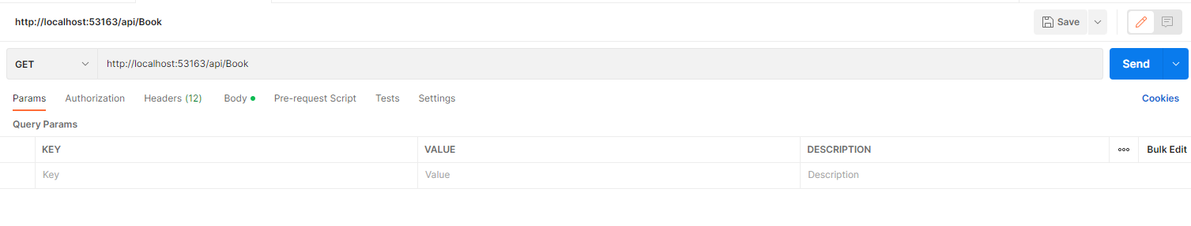

**Post**

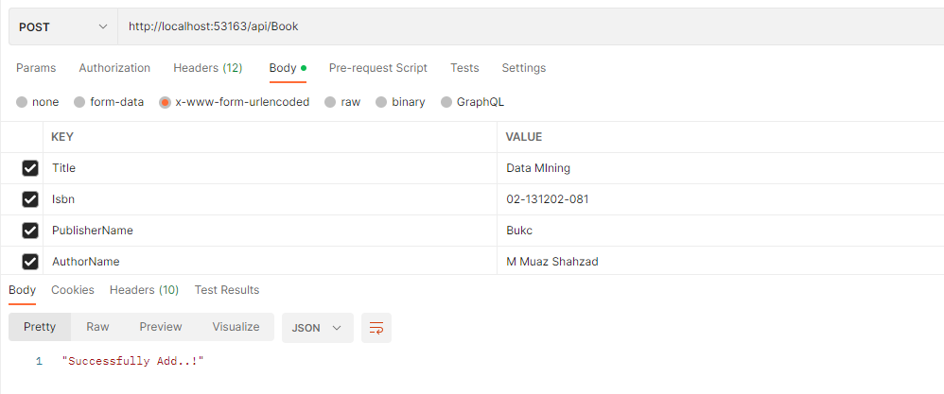

**Delete**



Id 4 data deleted.

**Put**

